**EXERCISE: 04**

**DATE: 20.11.2020**

**AIM:**

To write a python program to print a single string from two sets of strings received from user and swap the first two characters of each string

**PROGRAM:**

def swap_the_element(s):

st=""

for i in s:

st+=i

return st

x=input()

y=input()

st1=x.strip()

st2=y.strip()

if(len(st1)>=2 and len(st2)>=2):

tp1=list(st1)

tp2=list(st2)

cp1=tp1[0]

cp2=tp1[1]

tp1[0]=tp2[0]

tp1[1]=tp2[1]

tp2[0]=cp1

tp2[1]=cp2

st1=swap_the_element(tp1)

st2=swap_the_element(tp2)

print(st1,' ',st2)

else:

print("Invalid")

**LINK:**

[**http://103.53.53.18/mod/vpl/forms/submissionview.php?id=234&userid=1697**](http://103.53.53.18/mod/vpl/forms/submissionview.php?id=234&userid=1697)

**OUTPUT:**

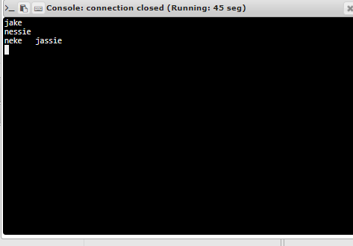

**RESULT:**

Thus the program is executed successfully